**Supplementary Materials**

**1.** **Supplementary Tables**

**Table S1: List of Alzheimer’s disease-associated neuropeptides (ADNPs).** See Li & Larsen (2023) for details.[1](https://paperpile.com/c/nQRnmI/6A3Z)

**Table S2. De-identified metadata for individuals and experiments included from the MIT ROSMAP Multiomics dataset.** Barcode, cell ID; EC, entorhinal cortex; projid, de-identified donor ID; Exc, excitatory. Refer to the ADKnowledge portal for detailed information on experimental design and assay.[2](https://paperpile.com/c/nQRnmI/Ss2l)

**Table S3.** **De-identified metadata for individuals and experiments included from the GTEx dataset.** SUBJID, de-identified donor ID; DTHHRDY, death classification based on the 4-point Hardy Scale. See GTEx publications for additional details.[3](https://paperpile.com/c/nQRnmI/zQlx)

**Table S4. Cell count for different cell types co-expressing various levels of neuropeptides (NP) in Alzheimer’s disease (AD) and control (ct) donor brains from the Grubman dataset.** Neu, neuron; ast, astrocyte; end, endothelial cell; mic, microglia; opc, oligodendrocyte precursor cell; oli, oligodendrocyte; low, expressing 0-1 NP; mid, expressing 2-5 NPs; high, expressing 6+ NPs. See Li and Larsen (2023) for details.[1,4](https://paperpile.com/c/nQRnmI/Mcrr+6A3Z)

**Table S5. The molecular process increased in control HNP neurons in comparison to control LNP neurons.** HNP neurons, neurons expressing high levels of NPs, proxied by co-expressing 6+ NPs; LNP neurons, neurons expressing low levels of NPs, proxied by co-expressing 0-1 NP.

**Table S6. Genes with significantly increased expression in HNP neurons.** HNP neurons, neurons expressing high levels of NPs, proxied by co-expressing 6+ NPs.

**Table S7. Summarization of generalized linear regression analysis of gene expression and number of co-expressed neuropeptides (NPs).** A generalized linear regression model was fitted for genes that had significantly increased expression in neurons expressing high levels of NPs (See Table 5).

**Table S8. Genes showing significantly decreased expression in AD MNP neurons.** MNP, neurons expressing medium levels (co-expressing 2-5) of NPs.

**Table S9. Molecular process increased in** Alzheimer’s disease MNP neurons in comparison to control MNP neurons. MNP neurons, neurons expressing medium levels of NPs, proxied by co-expression of 2-5 NPs.

**Table S10. Alzheimer’s disease-associated neuropeptides (ADNPs) show decreased expression with aging in early AD-impacted regions.** cor_estimate, estimate of correlation; **\*,** p_value<0.05, α = 0.05.

**Table S11: The expression of neuropeptides (NPs) that are not Alzheimer’s disease-associated NPs (ADNP) across brain regions with aging are not specific to early AD regions.** cor_estimate, estimate of correlation; **\*,** p_value<0.05, α = 0.05.

**Table S12. Neuropeptide (NP) expression and their change with age in each brain region.** RDS file of NP expression in brain regions included in this study. Row names,de-identified donor ID; DTHHRDY, death classification based on the 4-point Hardy Scale; SUM, cumulative expression of transcripts (log-transformed transcript per million counts).

**2.** **Supplementary Figures**

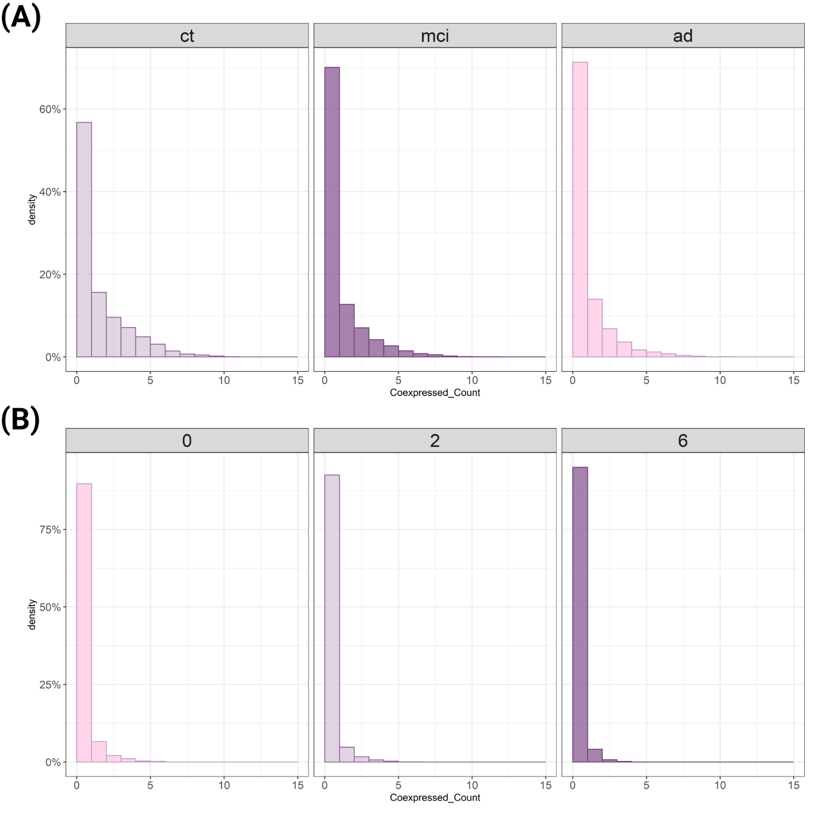

**Figure S1. Neurons from Leng and MIT ROSMAP Multiomics datasets showed insufficient neuronal populations expressing neuropeptides (NPs) (A)** Distribution of neurons based on the number of co-expressed NPs from the MIT ROSMAP Multiomics dataset. **(B)** Distribution of neurons based on the number of co-expressed NPs from the Leng dataset. ct, control; mci, mild cognitive impairment; ad, Alzheimer’s disease; 0, Braak stage 0; 2, Braak stage 2; 6, Braak stage 6. Coexpressed_count, number of co-expressed NPs.

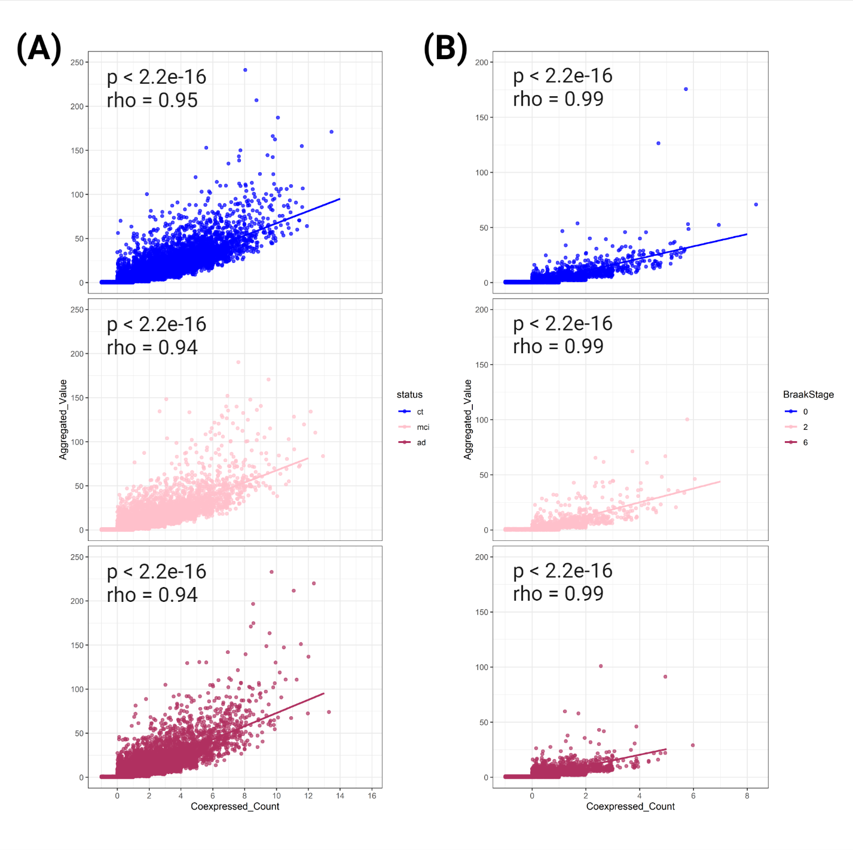

**Figure S2. The transcript level of neuropeptides (NPs) is highly correlated with the number of co-expressed NPs.** **(A)** Scatterplot showing the relationship between normalized transcript count and number of co-expressed NPs in neurons from the MIT ROSMAP Multiomics dataset. **(B)** Scatterplot showing the relationship between normalized transcript count and number of co-expressed NPs in neurons from the Leng dataset. The Spearman rank correlation test was used to calculate correlation and p-value. The correlation coefficient (rho) and p-values were reported. The significance cut-off was set at 0.05. ct, control; mci, mild cognitive impairment; ad, Alzheimer’s disease; 0, Braak stage 0; 2, Braak stage 2; 6, Braak stage 6.

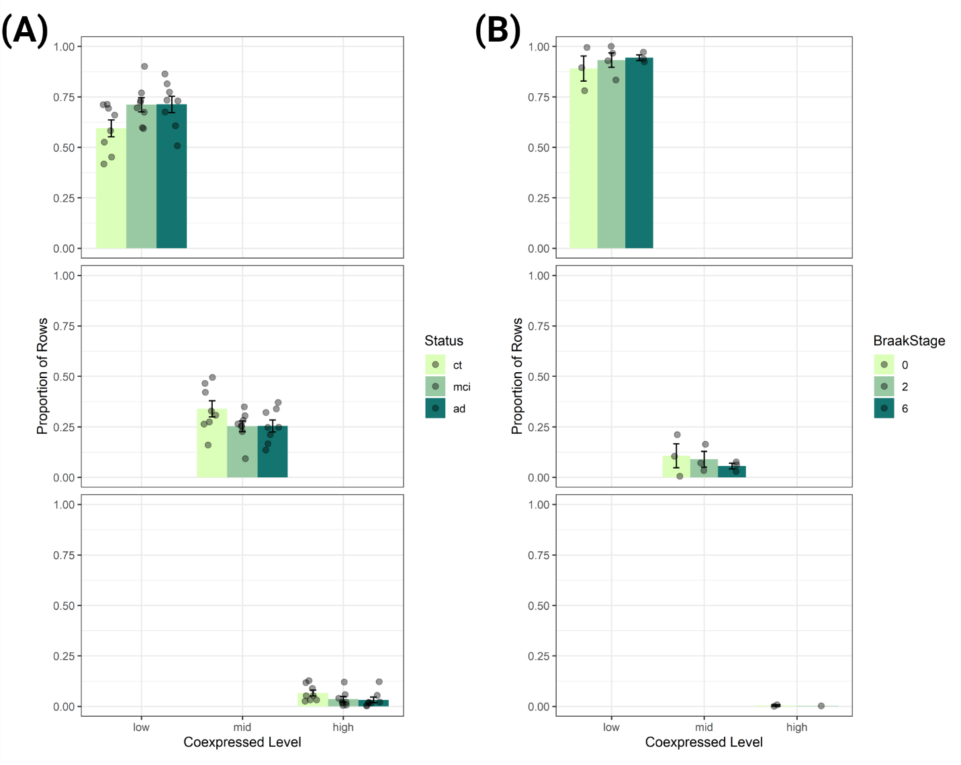

**Figure S3. Disproportionate absence of neurons in the high neuropeptides (NPs)-producing group where 6+ NPs are co-expressed. (A)** The distribution of neurons is based on the number of co-expressed NPs from the MIT ROSMAP Multiomics dataset. **B)** The distribution of neurons based on the number of co-expressed NPs from the Leng dataset. Note the complete absence of HNP neurons in Braak stage 6. low: 0-1; middle (mid): 2-5, and high: 6+. ct, control; mci, mild cognitive impairment; ad, Alzheimer’s disease; 0, Braak stage 0; 2, Braak stage 2; 6, Braak stage 6; HNP, neurons expressing high levels of NPs, proxied by co-expressing 6+ NP.

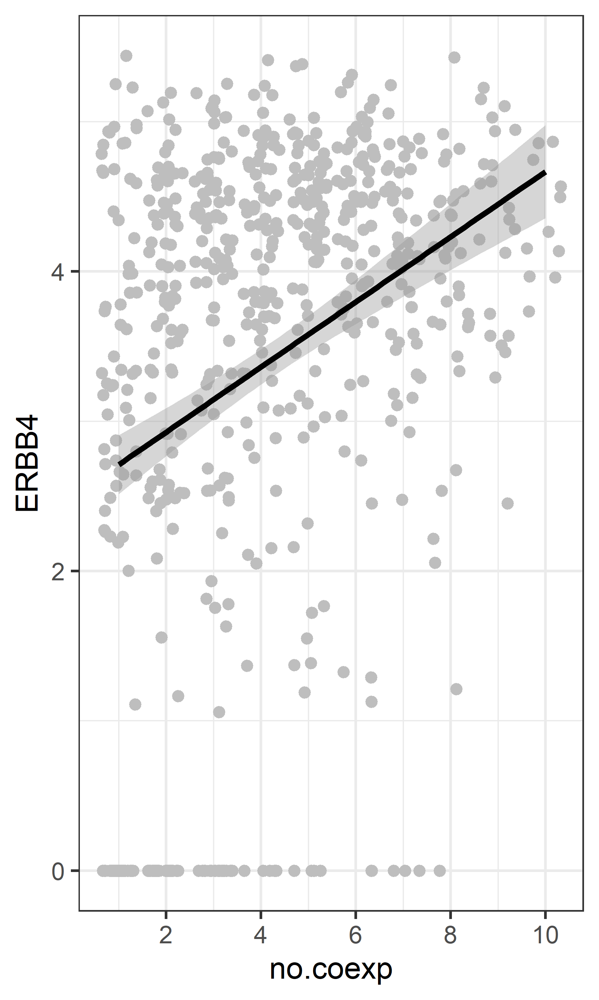

**Figure S4.** ***ERBB4* expression shares a significant positive correlation with the number of co-expressed neuropeptides (NPs) in neurons.** Scatterplot showing the relationship between normalized transcript count of *ERBB4* and number of co-expressed NPs in neurons from the Grubman dataset. No.coexp, number of co-expressed NPs.

**3. Code used for bioinformatic analysis**

See <https://github.com/mancili/HNP/code>

**Reference:**

1. [Li M, Larsen PA. Single-cell sequencing of entorhinal cortex reveals widespread disruption of neuropeptide networks in Alzheimer’s disease. *Alzheimers Dement*. Published online February 24, 2023. doi:](http://paperpile.com/b/nQRnmI/6A3Z)[10.1002/alz.12979](http://dx.doi.org/10.1002/alz.12979)

2. [AD knowledge portal. Accessed June 27, 2024.](http://paperpile.com/b/nQRnmI/Ss2l) <https://adknowledgeportal.synapse.org/Explore/Studies/DetailsPage/StudyDetails?Study=syn52293417>

3. [GTEx Consortium. The GTEx Consortium atlas of genetic regulatory effects across human tissues. *Science*. 2020;369(6509):1318-1330.](http://paperpile.com/b/nQRnmI/zQlx)

4. [Grubman A, Chew G, Ouyang JF, et al. A single-cell atlas of entorhinal cortex from individuals with Alzheimer’s disease reveals cell-type-specific gene expression regulation. *Nat Neurosci*. 2019;22(12):2087-2097.](http://paperpile.com/b/nQRnmI/Mcrr)